Sample Concentrator—ND200-1
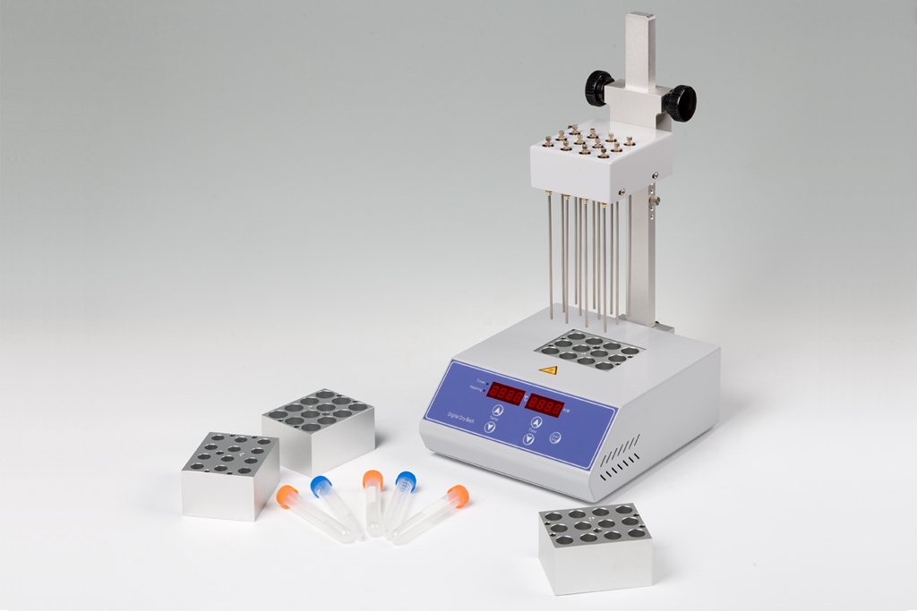
Description:
ND200-1 Sample Concentrator is with microprocessor controlled and PID fuzzy controlled technique. Instead of traditional water bath device, the heat-conducting medium is high purity aluminum. The Test tubes are held in a block, and blowing a large number of samples at one time. It can be used in residue analysis, commodity inspection, food, environment, pharmacy and biological product and other industries.

Features:
◆ High precision and wide range of tamp control.
◆ Blowing a large number of samples at one time.
◆ Blowing each sample independently.
◆ Amount of airflow can be adjusted.
◆ Easy operation; safe and reliable to use.

Applications:
- Analysis of pesticide residues: vegetables, fruits, cereals, plant tissue.
- Environmental analysis: such as drinking water, groundwater and polluted water samples.
- Biological analysis: such as hormone analysis, sample preparation of liquid phase and gas phase and mass spectrometry analysis.
- Food and beverage: such as milk, wine, beer, etc.
- Pharmaceutical drug testing: such as traditional Chinese medicine pharmaceutical, drug screening.

Parameters:
Model | ND200-1
Temp range | RT.+5℃-160℃
Temp accuracy | ±0.5℃(@40℃)
Temp accuracy | ±1℃(@120℃)
Temp uniformity | ±0.5℃
Display accuracy | 0.1℃
Timing range | 1min-99h59min/∞
Heating time | ≤15 min(from 25℃ to 160℃)
Needle length | 150mm
Nitrogen flow rate | 15L/min
Nitrogen pressure | 0.1Mpa
Block quantity | 1
Max power | 300W
Voltage | AC220V or AC110V, 50/60Hz
Dimension(mm) | 260X220X475
Weight(kg) | 6.0
Optional Blocks:
Type | Description | Type | Description
MD50 | 12x10mm | MD54 | 12x16mm
MD51 | 12x12mm | MD55 | 12x19mm
MD52 | 12x13mm | MD56 | 12x20mm
MD53 | 12x15mm | --- | ---

